Sincerely,
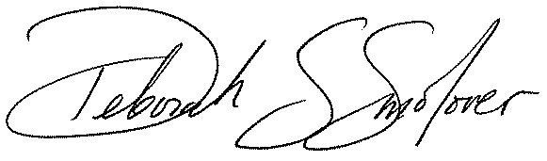

Deborah Smolover
Executive Director, America Forward
Managing Partner, New Profit

