Governor’s Youth Pay for Success 2018 Initiative
House Bill 18-1323, Signed into Law by Governor Hickenlooper in 2018, funds three Pay for Success Pilots to Improve Outcomes for Colorado Youth With High Risk Factors

The Challenge: Too often, government is ineffective at helping kids when they get into trouble, and supporting families and community members trying to steer them in a better direction. That’s true across the United States, and true in Colorado. We are failing far too many adolescents in the justice system, in foster care, or in too many cases, both. And this failure is costing the state millions of dollars a year. For example:
- Youth in the foster system become involved in the juvenile justice system at a high rate.
- 66% of Colorado youth who enter secure detention return at least once, and often more, as juveniles.
- Only 23% of Colorado youth in foster care graduate from high school on time.
- Proven community-based interventions are not available to many Colorado youth who could benefit from them.

Leveraging “Pay for Success” to Pay for Outcomes: Through bipartisan legislation in 2015, the Colorado legislature authorized the Governor’s Office of State Planning and Budgeting (OSPB) to use “Pay for Success,” an innovative model in which private or philanthropic upfront capital is used to fund preventative programs. This allows government to pay later for successful outcomes, when services produce high downstream benefits to taxpayers and society. At least half of state funding for the three pilot projects, summarized below, would not be paid until an independent evaluator certifies the pilots worked.
- House Bill 18-1323, a bipartisan bill sponsored by all six members of the Joint Budget Committee (three Democrats, three Republicans), was signed into law by Governor Hickenlooper in April 2018.
- The bill authorizes transfers into OSPB’s Pay for Success Contracts Fund, created by the 2015 law. This schedule of transfers over the next four years will support the launch of these three pilot programs.
- OSPB is working with Colorado foundations and impact investors to raise Pay for Success funding to cover the cost of the pilots while the evaluations run their course, prior to state “success payments.”

Three Pilot Projects: House Bill 18-1323 includes funding for three locally-developed pilots to produce measurably better outcomes for Colorado youth with high risk factors, and pay only if those outcomes are achieved. These three pilots – with a suburban, rural and urban focus – were selected from 61 proposals submitted through OSPB’s 2017 Call for Innovation.

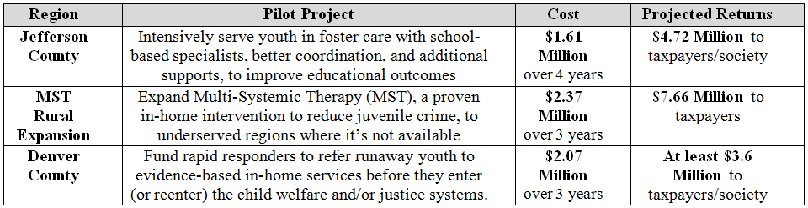
Note: Cost Benefit calculations based on OSPB analysis, using existing data on system-involved youth in Colorado

In short: Youth with high risk factors are slipping through the cracks. We have to do better. Pay for Success can help us try new approaches, while guaranteeing taxpayer dollars fund what works.

Supporters of 2018 Youth Pay for Success Initiative:
