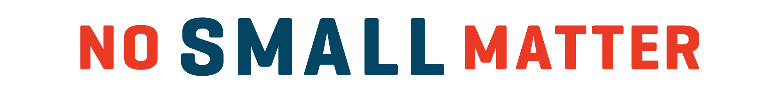

By redefining our public understanding of what’s happening inside children’s brains from birth to five, and illustrating the outsized importance of this developmental moment, the documentary film No Small Matter has one goal: to put how America supports families with babies and young children at the top of our nation’s social and political agenda.

What can you use this film for?
That depends on your goals! Here are some common ways policymakers, partners and advocates are using No Small Matter:

To raise awareness: No Small Matter was designed to present the issue of early care and education in an entertaining, informative, and non-partisan way, one that connects equally with influencers (policymakers and business leaders), caregivers (parents, grandparents, and family childcare providers), and other intersectional stakeholders (health professionals, k12 educators, employers, and more).

To motivate action: No Small Matter provides the perfect vehicle for gathering current and future advocates for strategic conversations that can galvanize change at the city, state, county, and federal levels.

To inspire: No Small Matter’s unique mix of humor, hope, emotion, and urgency can engage audiences in a way that no white paper or op-ed can, providing a powerful community experience that can challenge expectations and change minds.

How can you show it?

No Small Matter is available in a number of formats, depending on how and when you would like to use the film. While the filmmakers believe strongly in the power of seeing the full-length documentary in its entirety, we understand that it can be hard for anyone to make time to go to the movies — let alone parents, teachers, and policymakers! The film is available primarily by digital download, as well as DVD and blu-ray upon request. The following versions are available for use:

- Feature-length film: 75 min.
- Short: 45 min.
- Focus on ages zero-three: 35 min.
- Scenes from the film: 10-15 min.
Depending on your audience, a screening can be as simple as gathering folks in a conference room, a lunchtime briefing with lawmakers or renting out a theater for a big night out. Big or small, every host receives a screening kit that includes an event planning checklist, discussion guide template, press kit, and outreach materials.
Want to learn more?

Reach out to hello@nosmallmatter.com to learn more about how you can bring the story of early learning to life in your community.

